**WEEK 10 ASSIGNMENT BDWUP**

**CONNECT MS EXCEL INPUT WITH DIFFERENT OUTPUT(MS EXCEL WITH MS WRITER)**

**Aim:**

To connect data from a excel and writer file and click preview rows to verify the file is being read correctly.

**Algorithm:**

1.Start the process.

2.Create a Sales database using Excel.

3.Save the file in .xls format.

4.Open Pentaho Spoon tool for data integration.

5.Choose text input and text output for data retrieval.

6.Save the file.

7.Stop the process.

**OUTPUT:**

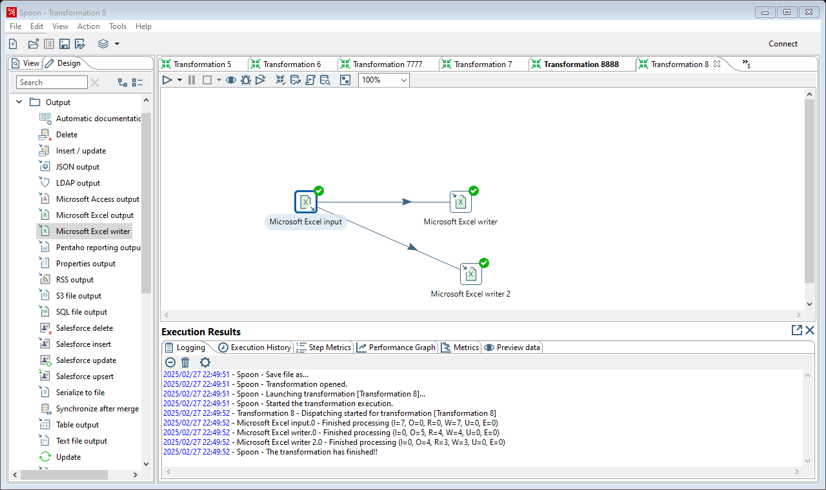

**Result :**

The above termination is executed successfully.